**Section 1: Summary**

**Our application is going to have a working name of “Business Pusher.” This application is going to showcase websites that our group has built and allow a potential client to create an account and contact us for a quote. Our business idea for this application is to create custom websites for clients and maintain them for a monthly fee. Having a website for your business is incredibly important in this age and this application would allow companies to outsource their website development to us so that they can focus on their normal business operations. Our target audience would be any company looking to expand their client base through the use of the internet. Our main website will have a showcase displaying the websites we have built, a login and registration system for new clients, and a review system for clients we have built websites for. The websites that we will be building for the showcase will be a painting website, an image sharing website, and a flash card website for studying. We will add an ecommerce website and a webpage that displays chosen news types using a web crawler if we have time.**

**Section 2: Wireframes**

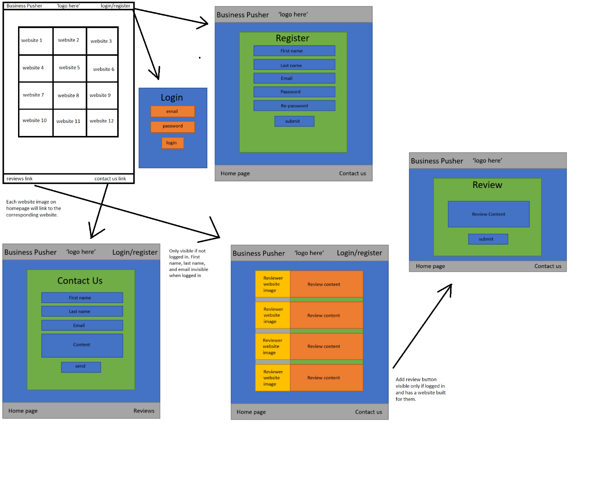

**Section 3: Feature List**

* **Main website**
  + **P0 User will be able to login or register**
  + **P0 User will be able to view websites we have built**
  + **P1 User will be able to contact us via email form**
  + **P2 User will be able to add reviews of our website as long as they have had one built for them**
* **Paint company website**
  + **P0 User will be able to contact the paint company**
  + **P1 User can view a carousel of images on the homepage**
  + **P1 User can leave a review of the website**
* **Flash card website**
  + **P0 User will be able to pick a topic and receive flash cards based on the chosen topic**
  + **P0 User’s questions answered correctly and incorrectly will be displayed**
  + **P1 User will be able to revisit questions with incorrect answers**
  + **P3 Flash cards will be randomized in each run through**
* **Image Sharing**
  + **P0 User will be able to login or register**
  + **P0 User can view other images that users have submitted**
  + **P0 User can submit their own images**
  + **P2 Each submitted image will have a thumbs up or thumbs down rating**
  + **P3 User can choose to sort images by rating or submission date**
* **Extras:**
  + **P3 Marketplace**
    - **User will be able to login or register**
    - **User can view available products**
    - **User can add products to a cart**
    - **User can purchase cart products**
  + **P3 Web crawler**
    - **User will be able to login or register**
    - **User can choose topic that the webcrawler picks**
    - **User can visit links that the webcrawler displays**

**Section 4: Technical Considerations**

* **Python – because it’s the language we’ve been learning**
* **MySQL – because it’s the database language we’ve been learning**
* **EC2 – because it’s free and easy to use**
* **Web crawler – as an extra feature**

**Section 5: Work Distribution**

* **Veso**
  + **Paint website**
  + **Image sharing website**
* **Tim**
  + **Main website**
  + **Flash card website**
* **Pair programming extra:**
  + **Marketplace**
  + **Web Crawler**